SIMATS ENGINEERING
ASSESSMENT TOOL 2: Case Study

COURSE NAME: | Cloud Computing and Big Data Analytics | COURSE CODE: | CSA1508

COURSE OUTCOME COVERED
CO3: Implement cloud-based solutions using cloud storage, web APIs, and platform services for real-world applications. (BL3)

Dave's Taxonomy: Precision (Level 3)  Question Count: 3 | Total Marks: 30

Code of Conduct
I P.MuniLokesh (192372181) (Name / Reg. No.) certify that this submission is my original work and that I have adhered to the guidelines specified for this assessment.
I understand that any violation of academic integrity rules will result in disciplinary action.
Signature of the student: P.MuniLokesh
Assessment Tasks
Case Study
- Case Study 1: Smart Retail Inventory Management System
A retail chain implements a cloud-based inventory system connected to store devices. Clients (POS systems and dashboards) communicate via APIs to centralized cloud services. Cloud storage stores product data, transaction logs, and analytics datasets. The system uses platform services for analytics and demand forecasting. Secure access is maintained through VPNs, firewalls, and API gateways. This solution integrates infrastructure, services, and web applications for efficient operations.

Case Study 1: Smart Retail Inventory Management System

1. Understanding of the Case
The retail chain needs a centralized system that keeps inventory data consistent across many stores while remaining responsive at the point of sale. The key requirements are:
- Real-time visibility of stock levels across all store locations.
- A common integration point for POS terminals and manager dashboards.
- Centralized, durable storage for product catalogues, transaction logs, and analytics data.
- Demand forecasting so stores can reorder stock proactively.
- Secure connectivity between distributed store networks and the cloud back end.

2. Application of Cloud Concepts
The system maps naturally onto a client–API–storage–platform-service architecture:
Architecture Layer | Component / Technology | Role in the System
Clients | POS terminals, manager/analyst dashboards (web app) | Capture sales transactions and present stock/analytics data to staff.
Web APIs | REST API Gateway (e.g., Amazon API Gateway / Azure API Management) | Single entry point that authenticates requests and routes them to backend microservices (inventory, sales, forecasting).
Cloud Storage | Relational database (transactions), NoSQL/data lake (product & analytics data), Object storage (reports) | Relational store guarantees ACID consistency for sales/stock updates; the data lake holds large historical datasets for analytics at lower cost.
Platform Services | Managed analytics/ML service (e.g.,  AWS Forecast, Azure ML, BigQuery  ML) | Runs demand-forecasting models without the retailer managing servers or ML infrastructure.
Network & Security | VPN / SD-WAN link per store, firewall rules, API gateway authentication | Protects the path between store networks and the cloud, and prevents unauthorised API access.

3. Analysis
Two trade-offs stand out. First, consistency versus availability: stock counts must be accurate enough to avoid overselling, but a strict, globally-locked database would slow down POS checkout during peak hours. A practical compromise is to keep per-store stock counts strongly consistent locally and reconcile with the central store asynchronously, accepting brief eventual consistency for cross-store visibility. Second, cost versus performance in analytics: running forecasting on raw transactional data would be expensive and slow, so transaction data is periodically pushed to a separate analytics store (a data lake) that the platform's ML service reads, keeping the operational database fast and lean.

4. Solution Design
Proposed flow: POS/dashboard clients → API Gateway (authentication, rate-limiting) → Inventory and Sales microservices → Relational database (current stock/transactions) with change-data-capture feeding a data lake → managed forecasting service → results surfaced back to dashboards via the same API layer. Each store connects to the cloud VPC over a site-tosite VPN; the API Gateway and a perimeter firewall restrict inbound traffic to authenticated, whitelisted sources. This design is feasible because every component is a managed cloud service, so the retailer scales storage and compute automatically as more stores are added, without provisioning physical servers per location.

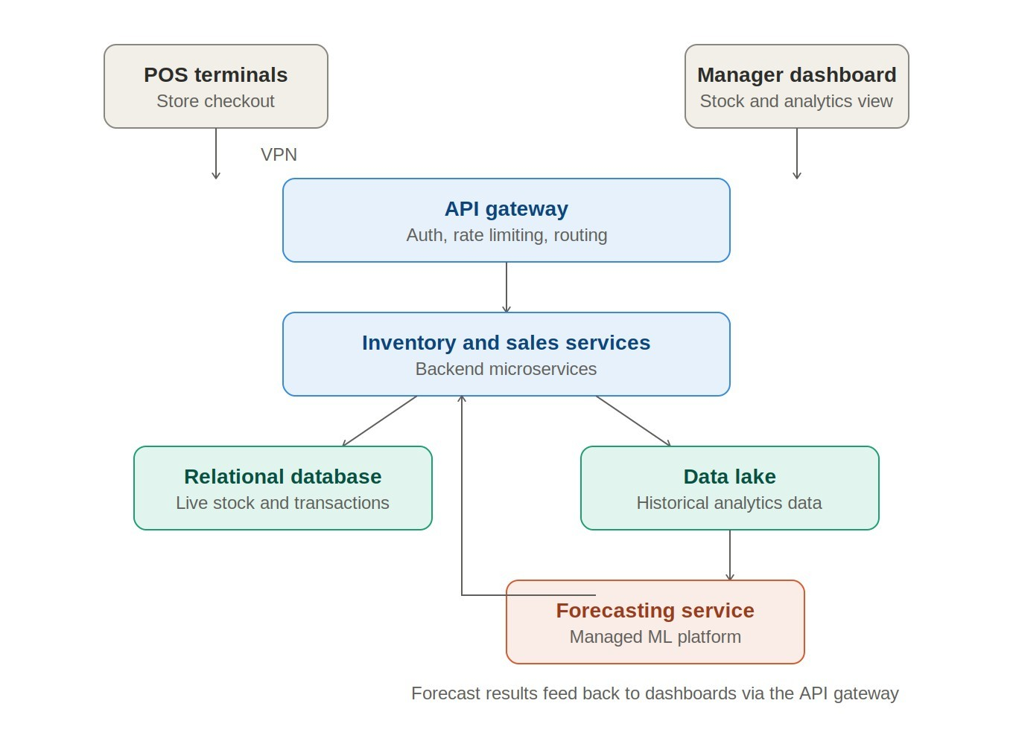

5. Security Justification
- VPN/SD-WAN — encrypts and isolates store-to-cloud traffic.
- Firewall rules — restrict which IP ranges/ports can reach cloud resources.
- API Gateway with token-based auth (OAuth2/JWT) — ensures only authenticated POS/dashboard clients call backend services.
- Encryption at rest and in transit for the database and data lake, protecting customer and sales data.

- Case Study 2: Cloud-Based Document Collaboration System
An enterprise deploys a document collaboration tool similar to Google Docs. Users access the platform via browsers, enabling real-time editing and sharing. Documents are stored in distributed cloud storage with version control mechanisms. Web APIs enable synchronization across multiple clients and devices.
Network infrastructure ensures low latency and high availability globally. Security includes encryption, identity management, and access permissions for collaboration.

Case Study 2: Cloud-Based Document Collaboration System

1. Understanding of the Case
This is a Google-Docs-style platform, so the defining requirements are real-time multi-user editing, consistent document state across devices, global low-latency access, and strong access control since documents may contain sensitive business content:
- Multiple users editing the same document simultaneously without overwriting each other's changes.
- Automatic synchronization across browsers/devices.
- Durable storage with version history so earlier states can be restored.
- Low-latency access for a globally distributed user base.
- Fine-grained sharing permissions and secure identity verification.

2. Application of Cloud Concepts
Architecture Layer | Component / Technology | Role in the System
Clients | Browser-based editor using  WebSockets | Provides the live editing surface and pushes/receives incremental changes.
Web APIs | REST API for document/folder management + WebSocket API for real-time sync | REST handles create/share/permission operations; WebSockets stream live edits with minimal latency.
Cloud Storage | Distributed object storage with | Stores document content durably; versioning
 | versioning (e.g., Amazon S3 + DynamoDB metadata) | preserves edit history and enables rollback.
Platform Services | Real-time collaboration/CRDT  (Conflict-free Replicated Data Type) or  Operational-Transform service; CDN | Merges concurrent edits deterministically without conflicts; CDN caches static assets close to users worldwide.
Network & Security | Multi-region deployment, TLS  everywhere, IAM/SSO, encryption at rest | Keeps latency low globally and protects documents against unauthorized access.

3. Analysis
The central trade-off is consistency versus latency during concurrent editing. A traditional locking approach (only one editor at a time) is simple but defeats the purpose of real-time collaboration; a CRDT or Operational Transform algorithm allows simultaneous edits to merge automatically at the cost of added engineering complexity. A second trade-off is global replication cost versus latency: storing full replicas in every region minimises latency but increases storage cost and raises data-residency questions, so most systems replicate metadata widely while keeping a primary copy per document with cached, CDN-delivered snapshots for read access.

4. Solution Design
Proposed flow: Browser client opens a WebSocket session to a regional collaboration service that runs the CRDT merge logic; edits are streamed to peers in the same session in real time and periodically checkpointed to versioned object storage. Document metadata (owner, permissions, version index) lives in a globally-replicated key-value store so sharing and access checks are fast anywhere. A CDN serves static assets and cached read-only document snapshots to reduce load on origin servers. Identity is managed through SSO/OAuth2, and every document object carries an access-control list evaluated by the API layer before any read/write is permitted.
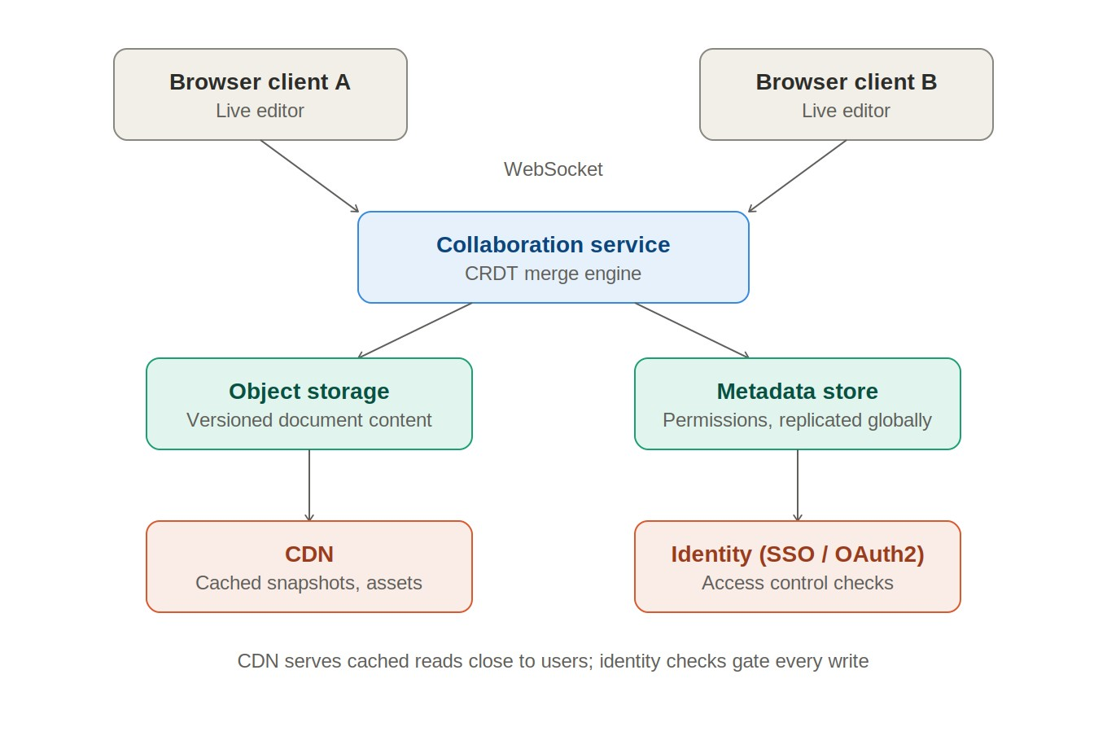

5. Security Justification
- TLS/HTTPS for all client-server and inter-service traffic.
- Encryption at rest for stored document versions.
- Identity federation (SSO/OAuth2) so access ties back to verified enterprise identities.
- Per-document ACLs enforcing view/comment/edit permission levels.

- Case Study 3: Online Food Ordering Platform
A startup builds a cloud-based food ordering system accessible via web browsers and mobile clients.
Frontend clients interact with backend services through RESTful Web APIs hosted on a cloud platform.
Cloud storage is used to store menu images, invoices, and customer data securely. The infrastructure uses virtual machines and managed Kubernetes for scalability and reliability. Security is enforced through authentication tokens, HTTPS, and role-based access control. The system demonstrates integration of clients, APIs, storage, and platform services in real time.

Case Study 3: Online Food Ordering Platform

1. Understanding of the Case
A startup food-ordering platform must handle unpredictable, spiky demand (meal-time rushes), support both web and mobile clients, and process payments and personal data securely:
- Consistent experience across web and mobile front ends.
- Reliable order placement and tracking even under sudden traffic spikes.
- Secure storage of menu images, invoices, and customer data.
- A backend that scales elastically and stays available during peak hours.
- Secure authentication and controlled access to sensitive operations (e.g., order management, payments).

2. Application of Cloud Concepts
Architecture Layer | Component / Technology | Role in the System
Clients | Web app and mobile apps (iOS/Android) | Let customers browse menus, place orders, and track delivery status.
Web APIs | RESTful APIs for menu, order, user, and payment services | Decouple front-end clients from backend logic and allow independent scaling of each service.
Cloud Storage | Object storage for menu  images/invoices; relational database for orders/customers | Object storage is cost-effective for static media; the relational database ensures transactional integrity for orders and payments.
Platform / Compute | Virtual machines for steady workloads  + managed Kubernetes for microservices | Kubernetes auto-scales stateless services (order, menu) up during rush hours and down afterward, optimizing cost.
Network & Security | HTTPS, OAuth2/JWT tokens, rolebased access control (RBAC) | Secures API calls, verifies user identity, and restricts actions by role (customer, restaurant, admin).

3. Analysis
The main design tension is elasticity versus cost. Provisioning fixed virtual machines for peak load wastes money during offpeak hours, so order-facing microservices are containerized and run on managed Kubernetes with horizontal auto-scaling, while less bursty components (e.g., a background reporting service) can stay on fixed VMs. A second consideration is datastore choice: order and payment data need strong transactional guarantees (favoring a relational database), whereas the menu catalogue and images are read-heavy and benefit from a content-delivery/object-storage approach for speed and cost efficiency. Payment handling also introduces a compliance trade-off — the platform should avoid storing raw card data and instead delegate this to a PCI-DSS-compliant payment gateway, reducing both risk and audit scope.

4. Solution Design
Proposed flow: Web/mobile clients → API Gateway (auth, throttling) → Kubernetes-hosted microservices (Menu, Order, User, Notification) that scale horizontally based on CPU/request-rate metrics → relational database for orders/customers with read replicas for reporting → object storage/CDN for menu images and generated invoices → external payment gateway invoked over HTTPS for transactions. RBAC differentiates customers, restaurant staff, and administrators at the API layer, and all inter-service and client traffic is encrypted with HTTPS. This design is practical for a startup because it starts small on Kubernetes' auto-scaling defaults and grows cost-proportionally with order volume, avoiding large upfront infrastructure investment.
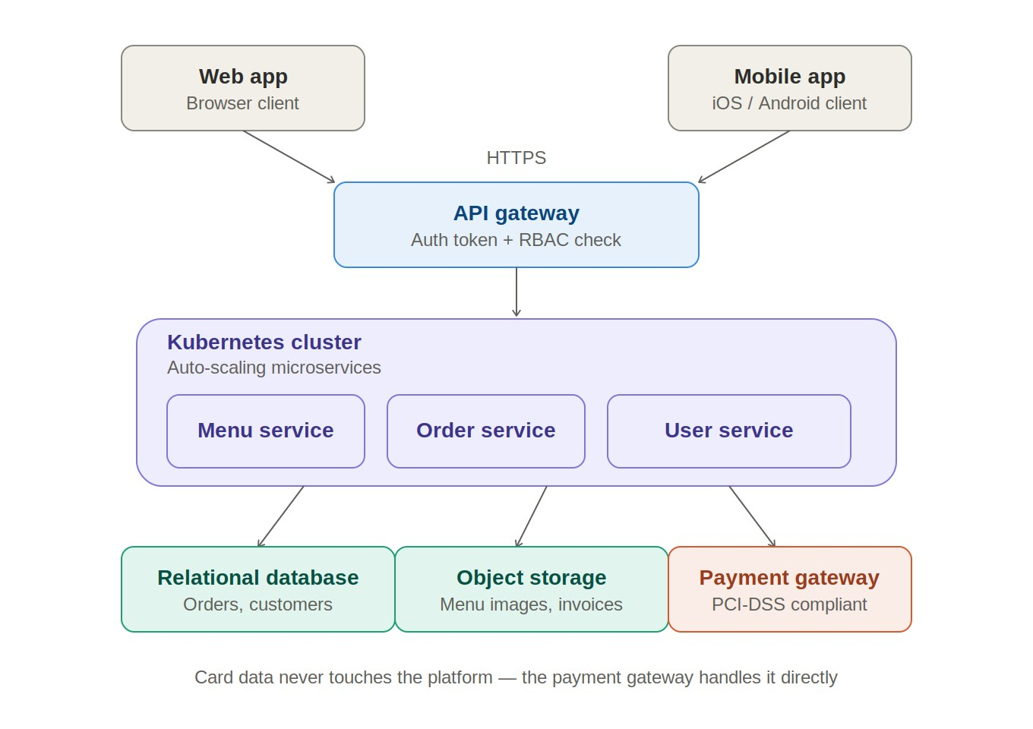

5. Security Justification
- HTTPS everywhere to protect data in transit, including payment requests.
- OAuth2/JWT authentication tokens to verify client identity on every API call.
- Role-based access control (RBAC) to separate customer, restaurant, and admin privileges.
- Delegated, PCI-DSS-compliant payment processing instead of storing raw card details.

Summary
Across all three case studies, the same cloud architecture pattern recurs: front-end clients communicate through Web APIs to backend services, which persist data in purpose-fit cloud storage (relational for transactional integrity, object/NoSQL for scale and cost efficiency) and rely on managed platform services (analytics/ML, real-time sync, container orchestration) to avoid operating raw infrastructure. Security is layered consistently — network-level protection (VPN/firewalls/HTTPS), identity-based authentication (OAuth2/JWT/SSO), and fine-grained authorization (ACLs/RBAC) — regardless of the domain. The differences lie in which trade-off dominates each scenario: consistency vs. latency for retail inventory, consistency vs. real-time collaboration for document editing, and elasticity vs. cost for the food-ordering platform.

Case Study Rubric

Criteria | Weightage | Level 4 - Exemplary | Level 3 - Proficient | Level 2 - Developing | Level 1 - Beginning | Total Marks
Understanding of Case | 25% | Clearly identifies all technical and business requirements | Identifies most requirements | Basic understanding only | Poor understanding of case
Application of Concepts | 25% | Applies suitable cloud concepts and tools effectively | Good application with minor issues | Partial application | Weak or incorrect application
Analysis | 20% | Strong analysis with clear trade-off reasoning | Reasonable analysis | Limited analysis | Minimal analysis
Solution Design | 20% | Solution is feasible, practical, and well justified | Reasonable solution with minor gaps | Basic solution | Unclear solution
Clarity | 10% | Well-structured and easy to follow | Mostly clear | Somewhat unclear | Poorly organized

